Change Default Web Browser – Windows 10
- Start by clicking the Windows Start button on the bottom left of your screen on your task bar. (If you have adjusted settings so the task bar is on the side this will look slightly different). It will look like this icon.

- Once this icon has been clicked, a new set of options will show up.

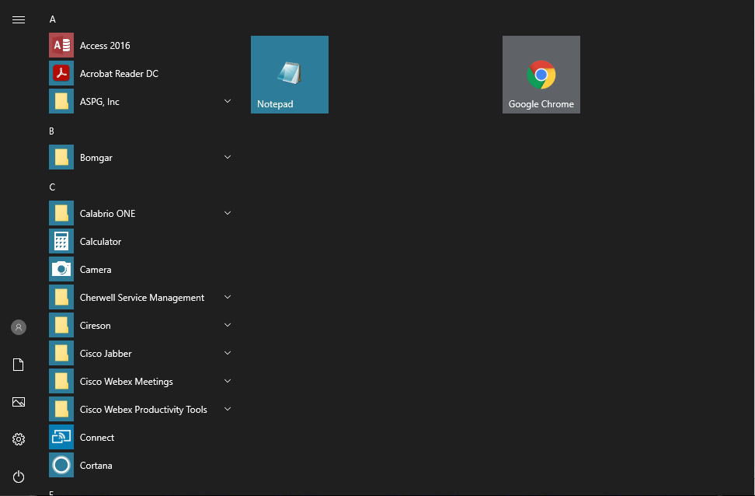

- Typing while this screen is open will trigger your ‘Windows Search’ option and will search your computer for any related files or settings that you might need. For this example we will want to type in ‘Default apps’ without the apostrophes. It should look like this if done correctly.

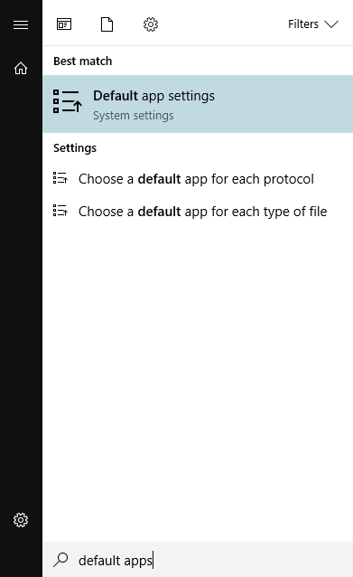

- Left click on the ‘Default app settings’ option that shows up, it will bring you into a list of options to change defaults for different applications you might use.

- If full screened, it should already show you the ‘Web browser’ option, but if you are in a windowed view you may need to scroll down a little to see the option. 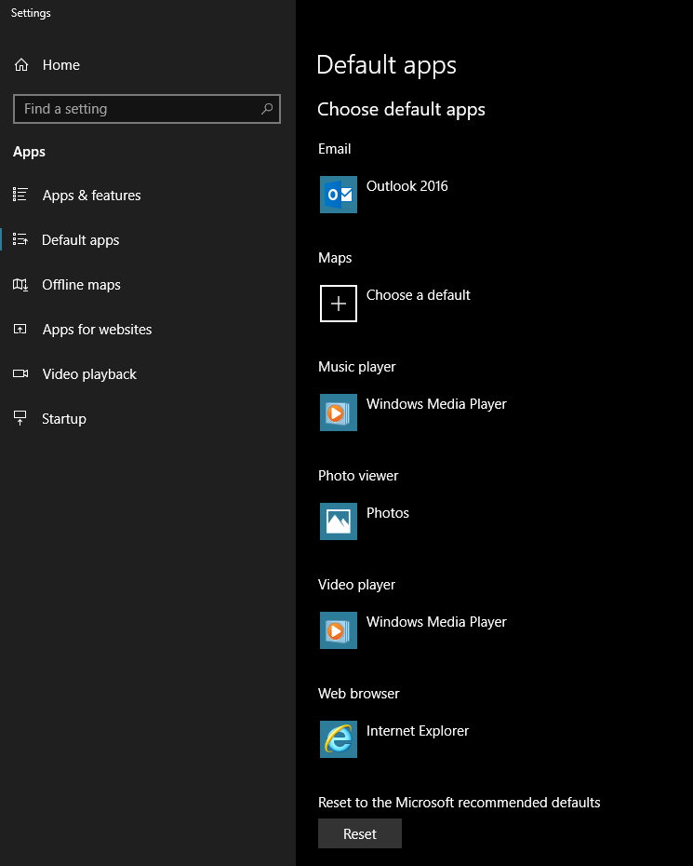

- Clicking on the ‘Web browser option will pull up all available web browsers to change to your default. Select the one that you want to change to your default by left clicking and then it should show up under the ‘Web browser’.

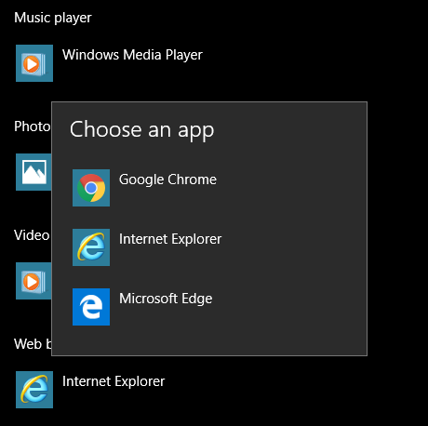

- You have now changed your default web browser. Any links that you click on or shortcuts to websites on your desktop will now open in the web browser that you chose.

Question: What about my favorites from my previous web browser, will they automatically be transferred over?
The favorites will not transfer automatically, you will have to go to the settings to do this. Below will show how to do this in both Internet Explorer and Chrome as they are the preferred web browsers for the state currently.

Internet Explorer:
- Open IE and in the top right of the window there should be a star icon that when hovered over turns gold. Click on this and it should turn gold fully and your favorites menu will show up.
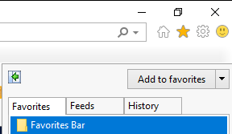

- Once this is opened, you can select the drop down option next to ‘Add to favorites’ and several more options will appear. You will want to select ‘Import and Export’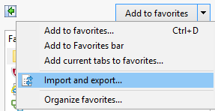

- Once you have clicked on ‘Import and Export’ option it should show the option to import from another web browser. Make sure this is selected and then hit ‘Next’

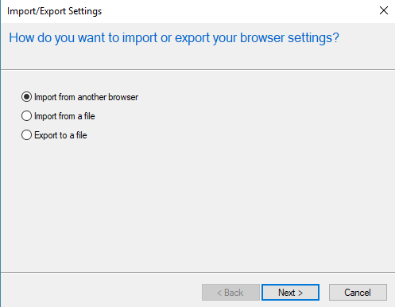
- After hitting ‘Next’ it will show you the list of available web browsers to import from. Select which you want to import from and then hit the ‘Import’ button.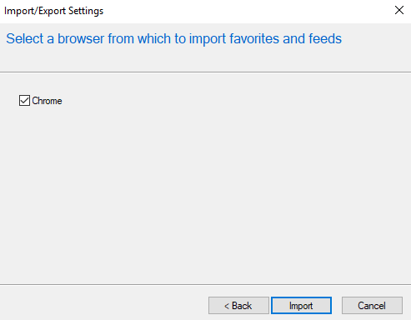

- After selecting ‘Import’ it will automatically pull any favorites that you have saved from that web browser and should now show up in your favorites menu.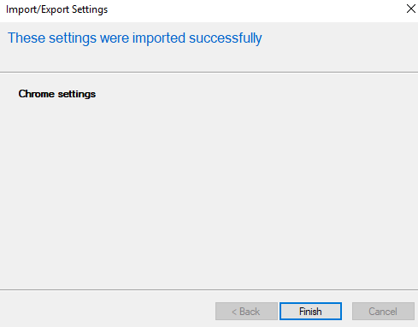
Chrome: (Chrome refers to ‘Favorites’ as ‘Bookmarks’. They both will function the same way to save often viewed pages for easy access).

- Open up Chrome and in the top right there will be an option button that looks like three vertical dots.

- Click this and it will open up a list of quick options. One of them should say ‘Bookmarks’

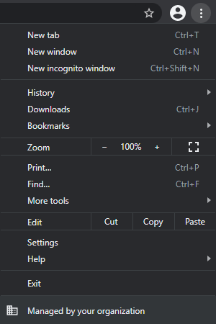

- Click on the ‘Bookmarks’ option, and several new options will show up

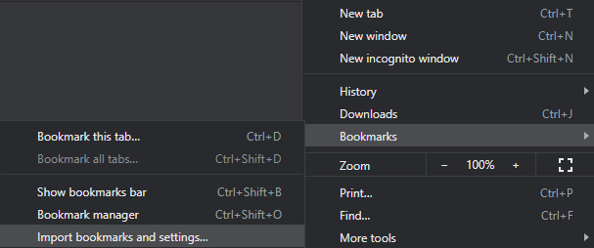

- Select ‘Import bookmarks and settings…’ and a new tab will open bringing you to your Chrome settings. 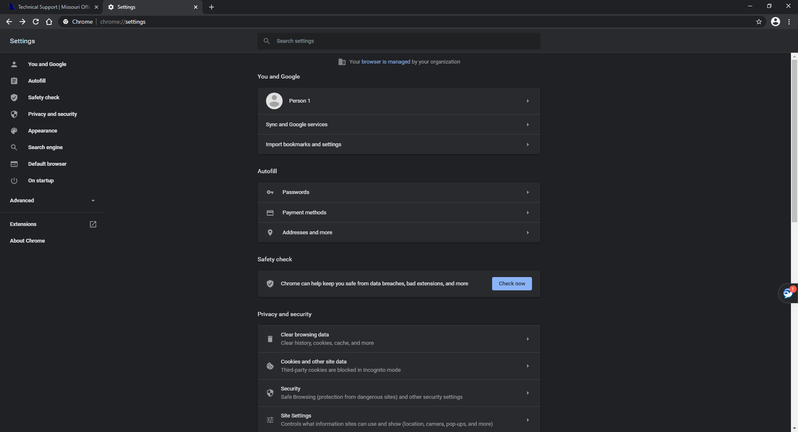

- The first area will say ‘You and Google’ and from there you can select the third option ‘Import bookmarks and settings’. A new window will pop-up allowing you select which web browser you would like to import from, and which settings you want to transfer over.

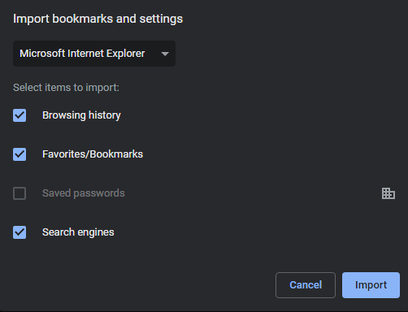

- Make sure the correct web browser is selected and that the ‘Favorites/Bookmarks’ option is selected. After this is done you can hit the ‘Import’ button in the bottom right.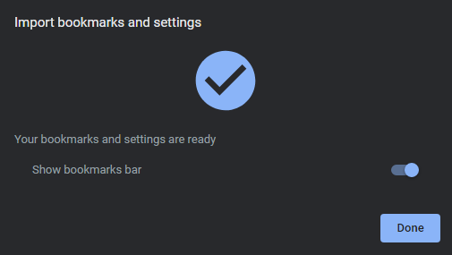

- You have now successfully transferred over your settings to Chrome. On there you can also select if you would like Chrome to show your bookmarks bar from the previous browser as well. Now when you go to ‘Bookmarks’ it will show all that was transferred over.

